**Lab 5**

**List the user commands and redirect the output to /tmp/commands.list**

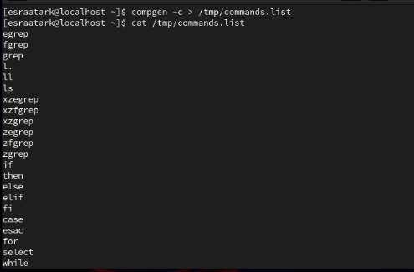

**Count the number of user commands**



**Get all the users names whose first character in their login is ‘g’.**

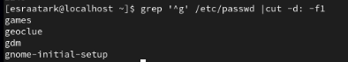

**Get the logins name and full names (comment) of logins starts with “g”.**

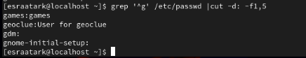

**Save the output of the last command sorted by their full names in a file.**

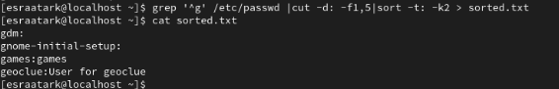

**Write two commands: first: to search for all files on the system that named .bash_profile. Second: sorts the output of ls command on / recursively, Saving their output and error in 2 different files and sending them to the background.**

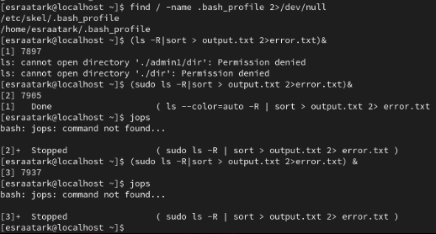

**Display the number of users who is logged now to the system.**



**Display lines 7 to line 10 of /etc/passwd file**

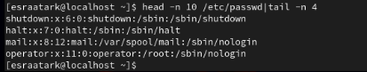

**What happens if you execute:**

* **cat filename1 | cat filename2**



Don’t output thing .This command has a mistake in it. The pipe (|) is used to send the output of the first command as input to the second command. However, cat filename1 | cat filename2 would result in an error because cat expects file arguments, but the pipe sends the output of filename1 to cat, which doesn’t make sense in this context.

* **ls | rm**



This command will **not work as expected**. Here’s why:

* **ls** lists the files in the current directory.
* **rm** deletes files. However, rm does not accept input from ls through the pipe like that.

Instead, rm will get the output of the ls command (which is a list of filenames), but rm will try to remove a file named "ls", not the files in the directory.

* **ls /etc/passwd | wc –l**



This command counts the number of lines in the output of ls /etc/passwd:

* ls /etc/passwd: Lists the file /etc/passwd (not the contents of the file). Since /etc/passwd is a file, ls will output a single line with /etc/passwd.
* | wc -l: Counts the number of lines in the output from ls, which will be 1

**Esraa tark foda**

**os**